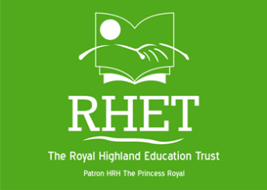
RHET Lothian
Super Sonic Spuds Registration Form 2024

To register your class for the Potato Project, please complete this form, including the photo permission form on Page 2, and email it to: lothians@rhet.org.uk
School Name:
Address:
Postcode:
Local authority:
Telephone:
Teacher’s email:
Online meeting platform
Teacher:
Class:
No. of pupils:
Experience of growing potatoes?

Do you have a school garden/vegetable patch?

RHET USE ONLY
Invited to Teacher Training?
Attending teacher training?
Collected resources:
Seed potatoes
Planting bag
Compost
Information pack
Risk assessment
Volunteer:
Date of class talk:
Initial potato weight:
Final harvest weight:
Comments:

Photo Permission Form
We at RHET kindly seek your permission to use your school name and/or photographs for future publicity.
Please note that you should check and comply with your local authority guidelines for
photographic and film consent before signing.
RHET staff and official photographers may take photographs or film during your event with RHET.
Photographers will have RHET certified name and / or press badges.
Photographs are an integral part of any charity publicity, giving body to a story about RHET’s work and enabling RHET to encourage more schools and teachers to become involved in taking the classroom to the countryside.

Please note that any photos/film taken by RHET may be used in the following ways:
Press
Photos may be sent to press accompanying news stories. Such press may be external local, national and specialist publications as well as RHET & RHASS publications for internal and external use on paper and e-publications.
Television & Radio
On occasion, reporters from TV and radio programmes have come along to an event where it is considered newsworthy. Although normally local news, RHET has in the past featured on BBC’s The One Show and Landward.
RHET Newsletters
Issued to schools, RHET host-farms and RHET supporters to document the Trust’s activities and events.
Promotional Materials
These include official RHET leaflets, banners, pop-ups and posters. Some may be used by RHET sponsors for similar publicity materials.
Websites
This includes the RHET website www.rhet.org.uk and associated websites such as those of our partners/funders.
RHET Social Media
Find RHET on Facebook and follow @TheRHET on Twitter. Pictures may be used to convey what RHET have recently been undertaking and achieving.

Please choose: I agree / I don’t agree

that RHET can take and use pictures/film of the class on this occasion providing no children’s names are used.
School Name/Teacher Name:
Signature: Date:

RHET USE
Event & Date: RHET Lothian Potato Project
NB: RHET will refrain from using images in our publications that we do not have permission for.
We cannot, however, be held responsible for images posted by other users.

